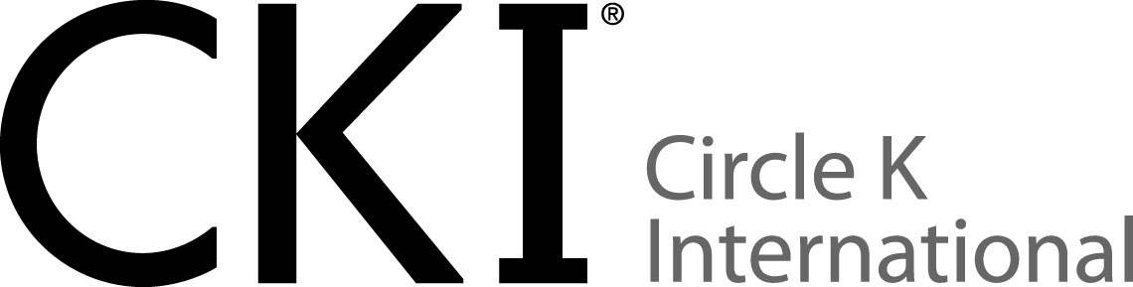

**Wisconsin-Upper Michigan**

**UW-Platteville**

**Meeting Minutes - Meeting #_3_, Date ( April 28th, 2022)**

**Attendance: # 15**

**Members: # 14**

**Guests: # 0**

**Kiwanis and advisors attended: # 1**

**Meeting:**

**Call to Order**

**Icebreaker: human knot**

**Pledges**

**Event Recap**

* 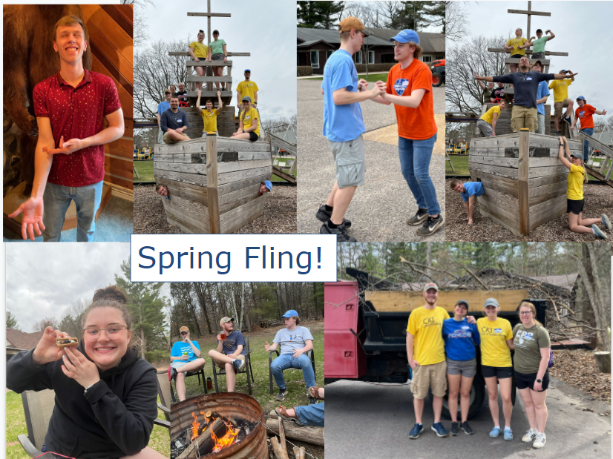
* **PCA Work Day 4/ 23**
* **Library Earth Day 4/23**

**Upcoming Events**

* Library STEM Activities
  + Saturday, April 30th 11am
  + Public Library
* Star Wars Day
  + Wednesday, May 4th 3-5pm
  + City Park - Costumes encouraged
* Ruby’s Pantry
  + Thursday, May 5th 3pm
  + 717 10th St, Waupaca, WI 54981
* M-Clean-Up
  + May 9th 4-5:30pm
  + The M

**FOR LIBRARY EVENTS**

**In order to volunteer with the library they ask you to fill out the background check attached to the email! Please and Thank you!!**

**Committees!**

* Service, Recruitment & Retention, Fundraising and Socials
* Meetings will occur after general meetings
* If you would like to lead a committee fill out form
  + <https://docs.google.com/forms/d/1dsfdBhQ4iTm0Gfn3JxvTG4KNxtNBb-ykkA3ICkNAK6w/edit>

**Attend District Events!**

* Meet a lot of new people
* 13 other schools in addition Platteville
* MORE & MORE Service

**Membership Dues**

* $20
  + TShirt, Dues, Club
  + Venmo: @CircleK-UWP
* If you are a paid member, please fill out the form below!
  + <https://forms.gle/dc7g7nVFwcdFK6aF8>

**🚨PLEASE KEEP TRACK OF YOUR HOURS🚨**

**Please use the QR Code below to enter and keep track of your hours to help us report them in our MRF!**

[**https://forms.gle/5owmgtThD6WCCxTm6**](https://forms.gle/5owmgtThD6WCCxTm6)

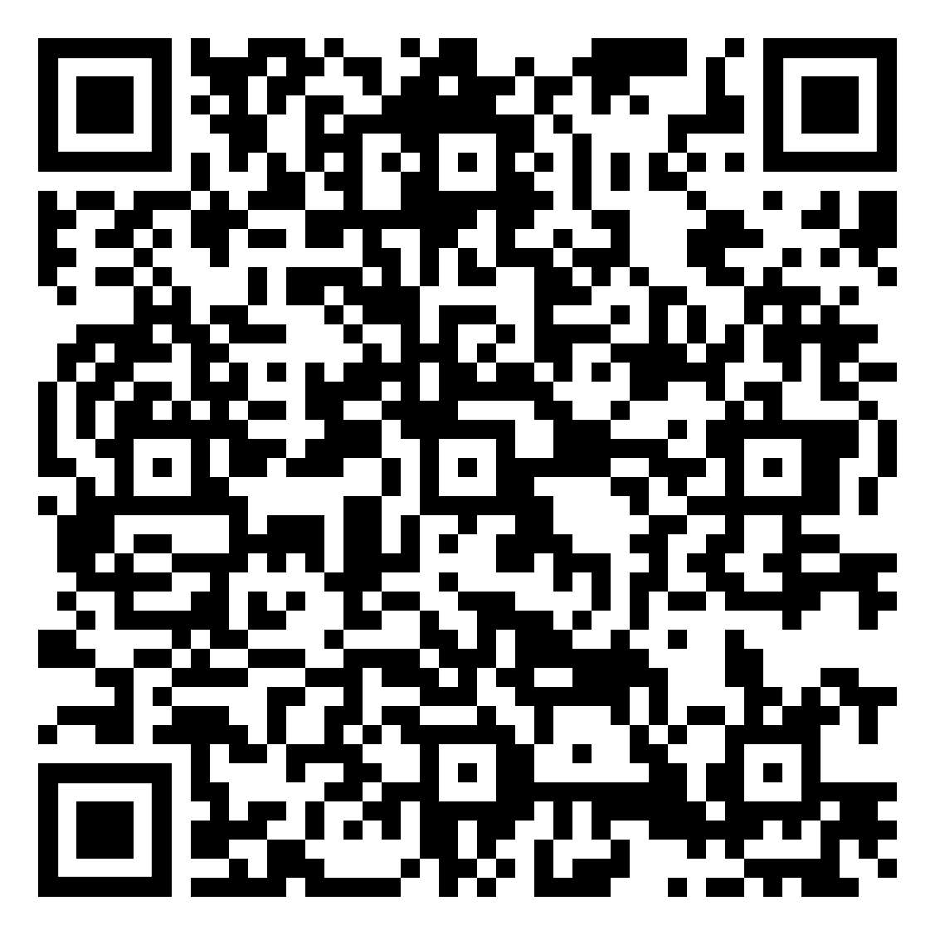

**NEXT MEETING!!!!**

**April 28th @ 6pm in Ullsvik 0115**

Thank you everyone who attended the meeting!

Have a great weekend!!

**LIVE to Serve! LOVE to Serve!**